**Publicity Calendar**

**(As of March 18, 2022)**

**Ongoing:**

Website Changes

* + - Domain, hosting info – tierra.net login: mbfair pw: fairfood! (you’ll go here to administer any payment changes, etc when the credit card needs to be updated. Jeanna Harkenrider has the login also and has updated cc before, but she won’t know when things are coming to expiration date, you’ll have to remind her)
    - WordPress: Contact List, Application Posting and Deadlines, Etc. url: mbfair.org/wp-admin and use your login to get online
    - Effective Marketing: Design changes to the site. We pay $200 a month for unlimited hours (Steve Snively [ssnively@verizon.net](mailto:ssnively@verizon.net))

System Administration - @mbfair.org email address administration

* Go to Office.com
* Login: [sysadmin@mbfair.org](mailto:sysadmin@mbfair.org)
* PW: HometownMB1!

Social Media

Update Instagram, Facebook Page and Twitter Page

(update “status” throughout the fair)

Instagram: mbhometownfair, pw: fairfood!

Facebook: <https://www.facebook.com/ManhattanBeachHometownFair/>

Twitter: https://twitter.com/mbhometownfair

Beach Reporter Ads

* + 1 page full color ad in Beach Reporter in Thursday before Fair, Submit by the Tuesday the week of the fair.
  + Contact: [jlemon@scng.com](mailto:jlemon@scng.com) about 2-3 months before the ad to reserve the space
  + Thank you ad after event (free Editors page submission), and on social media

**One Month Prior to Fair:**

Street Banners

About a week before the signs go up, drop them off at the City Yard on the cement table just inside the gate on the right. Before you drop off the banners, call or email Marcella Calloway mcalloway@manhattanbeach.gov to let her know to expect them. Send Marcella Calloway an email letting her know that they have been dropped off and that they should go up two weeks prior to the fair with the agreed upon locations from the city letter. At this time you will also need to email a completed Hold Harmless Agreement to Marcella Calloway mcalloway@manhattanbeach.gov The street banners come down the Monday after the fair, you will pick them up where you dropped them off, take to Vital Signs for new dates, and put them back in the storage unit.

City Yard Address: 3621 Bell Avenue, Manhattan Beach, CA 90266

**Two Weeks Prior to Fair:**

Posters/Signs

2 weeks prior to fair you will need to place an order. You will pick up all items on Friday, the day before the fair. In past we used Adam from Copy Shop. They direct bill the MB Fair or if you are given a receipt, you can send it to Jeanna Harkenrider for her to pay.

You are welcome to pull quotes from other vendors.

*What we typically order (Parade Signs that will be placed on each of the Woodie cars – 1 set per car:*

*Two each 16” x 24” Laminated posters of (for info booths):*

* + - * *Each confirmed Council member*
      * *President of Hometown Fair*
  + *Ask Joe and Dana what other fair signs need to be printed and laminated to the hung up around the fair. There were some for filming and covid last year, but maybe the filming one would be needed for this year? After you pick up, you’ll have to ask Joe and Dana where to hang them around the fair grounds.*

Podium sign – is in storage, so no need to reprint this year. It’s a logo of the MB Fair and it’s on foam core. You will be sticking this sign onto the mic podium that has to be moved to the front of Joslyn Center prior to the start of the parade on Saturday morning of day 1.

**Immediately After the Fair:**

Complete the Banner Application for the following year, we fight for spots and don’t want to lose out.

Get thank you letter from President for Beach Reporter letters to editor

Do thank you Ad for Beach Reporter

**Right after the fair this year:**

Change dates on Street Banners for the next year’s dates (always the first weekend of October.

We have 4 Banners – 3 White Banners with color font and 1 Blue Banner with white font. You need to pick up banners, clean them and take them to Vital Signs to have the date changed. Give Janey ([sbvs@earthlink.net](mailto:sbvs@earthlink.net)) a few weeks to update the dates. She will bill give you an invoice, you complete a check request form and send it to Jeanna (CFO) the invoice. Jeanna will send them a check directly.

**Minimal Advertising Schedule**

**(KEEPING FOR REFERENCE – I would leverage this schedule for our social media and digital marketing efforts)**

**January/February (sometimes do this) – Used to do this but don’t now**

*New Member Ad*

*Sample:*



**March**

*Applications are open for Vendors, Beer Garden, Soda and Water lotteries*

**July**

*More reminders about application deadlines, t-shirt contest, volunteers*

**August**

Work with Graphic Artist or create via Canva or Word to create 1 page ad

**2 weeks prior to fair**

T-Shirt Winner ad (didn’t do last year)

*½ page Fair Ad (didn’t do last year)*

**1 week prior to fair (Thursday prior to fair)**

*1 page full color Fair Ad*

*Sample:*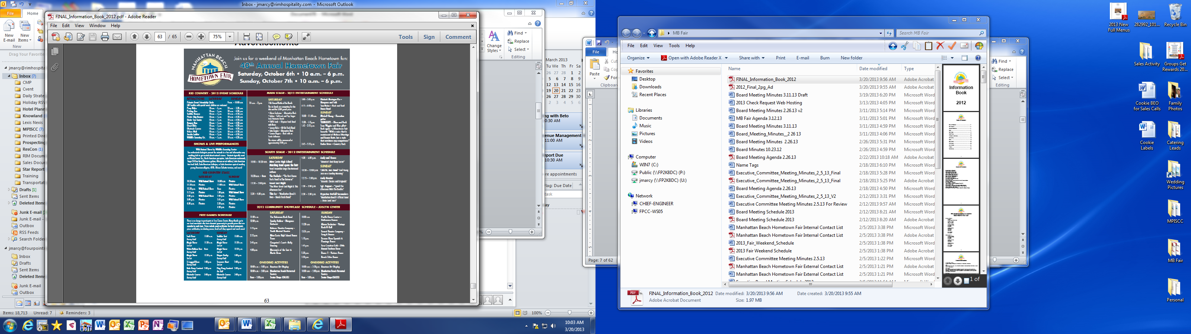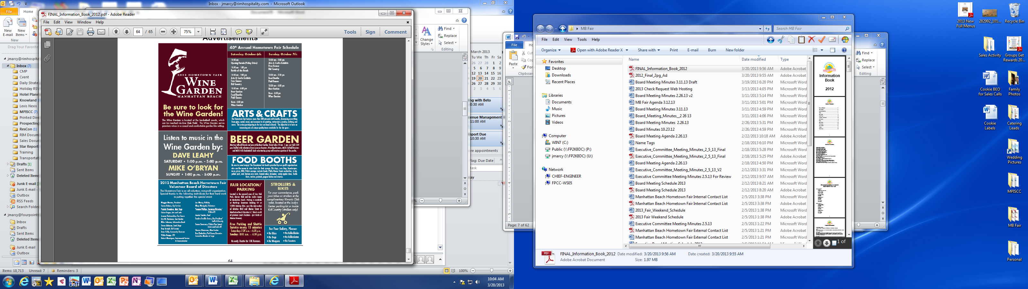

You will need to work with the entire board to make sure that all the times and performers are accurate. Again, we’ll need a new graphic designer. In the past, we’ve used Spectrum. (This I found to be the most challenging – good luck)

*¼ page Ad for T-Shirt Artist Winner*

*Sample:*



**1 week after the fair**

*Free Ads -*

*Notice of Public Meeting (BR will put in calendar section for free)*

*Letters to the Editor (just one from President)*

*Pick up street banners from city shed, inspect to see if replacement is needed, clean and put in Fair Shed*

**Important Contacts and Log ins**

**CONTACTS:**

Steve Snively

Effective eMarketing

1150 Shelley Street

Manhattan Beach, California 90266

(310) 871‐8856

[ssnively@verizon.net](mailto:ssnively@verizon.net)

Dropbox Login:

Login: [publicity@mbfair.org](mailto:publicity@mbfair.org)

PW: FairFood!

Website access:

[www.mbfair.org/sysadmin](http://www.mbfair.org/sysadmin)

[publicity@mbfair.org](mailto:publicity@mbfair.org)

password: fairfood!

Email system – 360 Office

Go to: Office.com

Login: [sysadmin@mbfair.org](mailto:sysadmin@mbfair.org)

Password: HometownMB1!

Twitter:

Mbhometownfair

Password: fairfood!

Instagram:

Mbhometownfair

Password: fairfood!

10K Chair(may want to do cross marketing)

Rachel Judson / Molly Taylor [molly@taylordigitalmarketing.com](mailto:molly@taylordigitalmarketing.com)

MB10K Race Committee

[mb10krun@yahoo.com](mailto:mb10krun@yahoo.com)

Ipower (old hosting company but let’s keep info in case)

Login MBfair

Password: Hometown45!

Tierra.net (I think they’re Domain / Hosting company)

Login: mbfair

Password: fairfood!

The Beach Reporter

Jenifer Lemon - sales department and send creative

[jlemon@scng.com](mailto:jlemon@scng.com)

**Street Banners / Application and installation**

Marcella Calloway

**Facilities Supervisor**

P: (310) 802-5311  
E: [mcalloway@manhattanbeach.gov](mailto:mcalloway@manhattanbeach.gov)

**Changing the Banner Dates annually**

Janey Fochs (Changes Dates on Street Banners)

South Bay Vital Signs

1001 E. Franklin Ave

El Segundo Ca 90245

310-640-0345

[sbvs@earthlink.net](mailto:sbvs@earthlink.net)

**Posters/Signs**

Adam

The Copy Shop

310-374-3666

309 S. Sepulveda Blvd.

Manhattan Beach, CA 90266

[www.CopyShopMB.com](http://www.copyshopmb.com/)

[adam@copyshopmb.com](mailto:adam@copyshopmb.com)

**Parade Contacts**:

Parade Description doc on Dropbox: <https://www.dropbox.com/home/MB%20Hometown%20Fair%20Files%20-%20Betty/PR/Parade?preview=PARADE+description.docx>

City Council: <https://www.manhattanbeach.gov/government/city-council> (hover over their names to find their emails)

Woodie cars main POC: Dave Rusher, and Victoria

[drusher@rusherair.com](mailto:drusher@rusherair.com)   
Victoria Hursey-Price [vhursey@rusherair.com](mailto:vhursey@rusherair.com)

Boy Scouts:

Rick Reeley <ReeleyR@cmtlaw.com>

Michael Tauber <iantauber@hotmail.com>,

mike tauber [mtauber@troop849.org](mailto:mtauber@troop849.org)

Girl Scouts:

Erin Mehta <erin104@gmail.com>

Christine Koh Leudeke <christinekoh75@hotmail.com>

MCHS Marching Band:

carolyn.mukai@verizon.net

[tina@shivpuri.com](mailto:tina@shivpuri.com)

[jcarlson@manhattan.k12.ca.us](mailto:jcarlson@manhattan.k12.ca.us) (Joel Carlson – band director)

MBMS (middle school) Choir:

[kcrellin@mbusd.org](mailto:kcrellin@mbusd.org) (Kate Crellin)

**Administering MBFair.org emails and password resets**

Go to Office.com

Login: [Sysadmin@mbfair.org](mailto:Sysadmin@mbfair.org)

HometownMB1!

1. Click on the 9 dots in the corner top left to show this menu:
2. Select ADMIN from the drop down menu

1. Select Active Users
2. Hover over the inbox you want to reset, a small key will appear in the line to do the reset PW action

1. Perform the actions in this screen, you can opt to provide the PW to the board member themselves, or send the PW info to their personal email so that they will receive it directly:

I’ve recently changed the option for existing board members to reset their own passwords. This should only need to be done for new members.