|  |  |
| --- | --- |
|  | **Manhattan Beach Hometown Fair General Board Meeting**  Date**: 8/27/24**  Time**: 6:30 dinner; 7:00 pm Meeting**  Location**: Joslyn Community Center, Sunrise Room**  1601 N Valley Dr, Manhattan Beach, CA 90266 |

**DRAFT AGENDA for Aug 27, 2024**

**Time                       Topic - Owner**

6:30 - 7:00 pm     Dinner –  Nicky. [Food signup](https://www.signupgenius.com/go/8050D48ADAD29A5FA7-48754746-fair/159118150#/)

7:00 pm   Welcome, Rollcall and approval of 8/13/24 minutes – Dana/Karen

* 7 If no one signs up before 8/27, we will pull name from a hat during meeting.

7:05 – 7:10 pm    City Council liaison remarks – Joe Franklin

7:10 – 7:30 pm     President’s remarks. –Dana, including:

* Tent permit / Special Event permit updates
* Choura updates / interest in walk-through
* Van
* Mapping needs / getting ahead of it
* City meeting output

7:30 - 7:35 pm      Treasurer’s Report – Jeanna

7:35 – 7:45 pm  Committee progress: Parade, Storage – (Ryan, Kim) +++

<https://docs.google.com/spreadsheets/d/1_epJDiSljVx1slpaUlM4MPWo4heLXSYvEiYO2dYusWo/edit#gid=0>

* + Rusher has been notified of no woodies this year

7:45 – 8:30 pm Around the room – Share pertinent items / requests for help. Likely topics:

* + Prep for 9/10, COIs, Apps, Health Dept, walk-throughs, BOB, maps

8:30 – 8:35 pm           Final notes and off to optional Happy hour (Hennessey's)

**Board Member attendees:**

|  |  |  |
| --- | --- | --- |
| **Wayne Bush** | Vice President & Beer Garden | Y |
| **Kari Carpino** | Merchandise | N |
| **Tamarie Cuneo** | Arts & Crafts | Y |
| **Kim Edwards** | Info Booth, FS, CC | Y |
| **Mark Finley** | Main Stage | N |
| **Nikol Fisher** | Marketing & Communications (Publicity) | Y |
| **Erin Freeman** | Wine Garden | Y |
| **Robin Geisen** | Dietz Stage | N |
| **Bruce Greenspon** | Traffic & Safety | Y |
| **Alex Haglund** | Food 1 | Y |
| **Jeanna Harkenrider** | Treasurer | Y |
| Robert Manriquez | ES & Comms | Y |
| **Joe Marcy** | Volunteer Recruitment | Y |
| **Dana Old** | President | Y |
| **Val Pagett** | Games | Y |
| **Nicky Quinn** | Kid Country | Y |
| **Ryan Shaw** | Community Relations | Y |
| **Kimi Thompson** | Food 2 | Y |
| **Karen Tokashiki** | Secretary & City Services | Y |
| **Joe Touch** | Community Showcase | Y |
|  |  |  |
| **Joe Franklin\*** | City Council Liaison | Y |

**MINUTES for Aug 27, 2024**

**Time                       Topic - Owner**

7:00 Welcome, Rollcall and approval 8/13/24 minutes – Dana/Karen

* Meeting called to order at 7pm
* Erin made motion to approve 8/13/24 minutes, Kim seconded it; all in favor, none opposed => minutes approved.
* Thanks to Nicky for the delicious dinner!

7:05 Connections – Dana

* “What are you most excited for / looking forward to over fair weekend?”

7:10 City Council liaison remarks – Joe Franklin

* Lot 3 closure – We do not expect impact to fair;
* However, Dana/Wayne/Karen will discuss shuttle w city traffic engineer during Special Event meeting

7:40     Treasurer’s Report – Jeanna

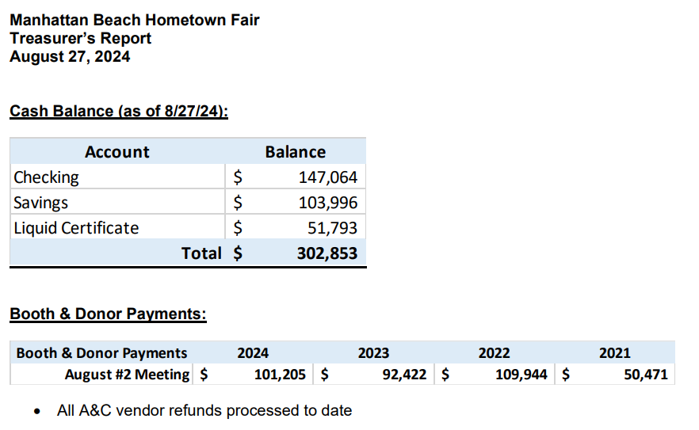

* **Outstanding proof of insurance certificates – DUE 9/15; dates on cert must cover dates of fair**
  + All food booths
  + All Kid Country vendors
  + Wine Garden Volunteer Groups (note: Beer Garden groups covered under MBX
  + via Food)
  + Kinecta – for parking lot – not required for City, but insurance provider thinks it is good due diligence for us to get a copy
  + Anheuser-Busch
  + LA Rugby Club

• If you need any deposits or pre-fair payments, please complete check request form and I will

get those processed ASAP.

7:10 **President’s remarks and around the room**

* Dana:
  + Sept. 10th – safety meeting is very important! Make every attempt to make it.
    - **Reminder that timing is bumped up 30 minutes; dinner at 6, meeting at 6:30**
    - 1st portion of meeting is safety agenda with city contacts; then board meeting
    - If interested, reminder to record the debate
* City personnel changes – fire dept., public works, city manager
* Tent permit / Special Event permit updates
  + still in process, will likely cost ~$2-4k for engineering
  + Joe Franklin may have one more option for us
* Parade – Rusher has been notified of no woodies this year; no issue
* Choura: Dana scheduling walk-through for them and interested board members
  + **9/10 at 1pm**
  + Dana sent note to Choura, bccing Robert, Erin, Robin, Bruce, Wayne
  + Let Dana know if you would like to also attend
* Special 10k run pre-fair run, if you would like to attend; Dana sent email
* Van decisions
  + Thursday pick-up, Monday drop-off
  + Erin will reserve; multiple drivers and ‘loaders’. True team effort.
  + Robert will have a lockbox to keep key.
  + Use cases:
    - Transport of large items
      * get your own smaller things from storage;
    - Keep wine safe overnight during weekend
* Joe M.: Mary Morigaki will be helping up
  + Super volunteers will get light blue Tshirt
* Nikol:
  + let her know of opts to push to social media
    - examples: final pushes for apps, ‘wholesome’ new entrants in CP
  + Nikol/Ryan to work on donor posts
  + Working on beach reporter ad
* Nicky: vendors set; will have age limits for some bouncies for safety
* Ryan: New: Terranea item
  + Erin suggested adding raffle desk to buy tickets for raffle in wine garden
  + Joe Franklin working some leads
  + Ryan/Joe M to get him asst chair
  + Parade reminders going out in Sept. No new adds
* Val: Secured lots of prize coupons for games; cool prizes include lighted up skateboard; working on more paid games booths
  + Val to let people know if needs help on booth field layout, etc.
* Kari – Merch orders – samples expected at 9/10 meeting
  + Order shirts that say “**Safety”, NOT Security** for wine and beer exit volunteers
    - Dana already sent note to Kari, Erin, Wayne, Bruce
  + Board will get $35 credit for at-cost items
* Wayne –
  + **Please respond to BBQ invite list ASAP; i**nvites by end of next week
  + Working TV truck
    - Offline - **Give Wayne your thoughts on if worth paying for, will bring vote nxt meeting, if needed**
  + Beer volunteer meeting 9/4
* Kim –
  + Community place is morphing into a very positive place
  + will get together with Nikol for social media opts
  + No major storage updates; will ping group for help as needed
* Tamarie – all good
* Erin, ,
  + wine volunteer meeting 9/3
* Joe T– all good
* Robert M / Karen to work through city-owned trash cans and ensure there is a plan for disposal
* Alex/Kimi:
  + Pizza
    - Will staff pizza from beer garden volunteers
    - Wayne – make sure to add to list
    - Alex/Kimi – must let Dana know if you need 10x10 added to Choura order.
    - Alex/Kimi – make sure you have netting from storage.
    - Alex/Kimi – make sure you fill out necessary paperwork for Beach Pizza.
* Bruce:
  + Need sketches of wine and beer garden for fire dept. assessment of capacity- (done)
  + 911 Emergency cards in all booths and venues.
  + Dana took lead with email 8/28; all venues will need to add booth locations/numbers
* Karen:
  + Need maps/layout of field booths by Sept. 18th – Alex in charge.
  + Emergency cards with board numbers and comm channels will be provided at the safety meeting.
  + Public works alignment meeting 8/28
* Joe M. Best of Manhattan nominations coming - think of ways to promote fair

8:30 – 8:35 pm           Final notes and off to optional Happy hour (Hennessey's)

* Next meeting September 10th – Safety Protocols
  + **6pm dinner**
  + **6:30pm meeting**

*Robert. made a motion to adjourn at 8:28 pm. Kim seconded. All in favor. Meeting adjourned.*

Minutes Approved by:

___________________________ ______________________

Dana Old, President Karen Tokashiki, Secretary