|  |  |
| --- | --- |
|  | **Manhattan Beach Hometown Fair General Board Meeting**  Date**: 8/13/24**  Time**: 6:30 dinner; 7:00 pm Meeting**  Location**: Joslyn Community Center, Sunrise Room**  1601 N Valley Dr, Manhattan Beach, CA 90266 |

**DRAFT AGENDA for Aug 13, 2024**

**Time                       Topic - Owner**

6:30 - 7:00 pm     Dinner –  Kimi T. [Food signup](https://www.signupgenius.com/go/8050D48ADAD29A5FA7-48754746-fair/159118150#/)

7:00 - 7:05 pm   Welcome, Rollcall and approval of 7/9/24 minutes – Dana/Karen

7:05 – 7:10 pm    City Council liaison remarks – Joe Franklin

7:10 – 7:30 pm     President’s remarks. –Dana, including:

* Tent permit / Special Event permit updates
* Choura updates
* 2024 Political campaigns – protocol. We are to steer clear of campaigning, endorsing and discussing in formal Board settings (meetings, emails, etc)
* Communication / proactive behavior / responsiveness
* Loose review of fair weekend flow (Weds – Mon)

7:30 - 7:35 pm      Treasurer’s Report – Jeanna

7:35 – 7:45 pm  Committee progress: Parade, Storage – (Ryan, Kim) +++

<https://docs.google.com/spreadsheets/d/1_epJDiSljVx1slpaUlM4MPWo4heLXSYvEiYO2dYusWo/edit#gid=0>

7:45 – 8:30 pm Around the room – Share pertinent items / requests for help. Likely topics:

* Final city letter, final parking passes, final merch elements, health dept updates, application status, BOB, assistant chairs, corp donors, etc.

8:30 – 8:35 pm Final notes and off to optional Happy hour

**Board Member attendees:**

|  |  |  |
| --- | --- | --- |
| **Wayne Bush** | Vice President & Beer Garden | N |
| **Kari Carpino** | Merchandise | Y |
| **Tamarie Cuneo** | Arts & Crafts | Y |
| **Kim Edwards** | Info Booth, FS, CC | Y |
| **Mark Finley** | Main Stage | Y |
| **Nikol Fisher** | Marketing & Communications (Publicity) | N |
| **Erin Freeman** | Wine Garden | Y |
| **Robin Geisen** | Dietz Stage | Y |
| **Bruce Greenspon** | Traffic & Safety | Y |
| **Alex Haglund** | Food 1 | Y |
| **Jeanna Harkenrider** | Treasurer | N |
| Robert Manriquez | ES & Comms | Y |
| **Joe Marcy** | Volunteer Recruitment | Y |
| **Dana Old** | President | Y |
| **Val Pagett** | Games | Y |
| **Nicky Quinn** | Kid Country | N |
| **Ryan Shaw** | Community Relations | Y |
| **Kimi Thompson** | Food 2 | Y |
| **Karen Tokashiki** | Secretary & City Services | Y |
| **Joe Touch** | Community Showcase | Y |
|  |  |  |
| **Joe Franklin\*** | City Council Liaison | Y |

**MINUTES for Aug 13, 2024**

**Time                       Topic - Owner**

7:00 Welcome , Rollcall and approval 7/9/24 minutes – Dana/Karen

* *Meeting called to order at 7pm*
* Erin made motion to approve 7/9/24 minutes, Kim seconded it; all in favor, none opposed => minutes approved.
* **Thanks to Kimi for the delicious dinner!**

7:05    Connection exercise - Dana

7:10 City Council liaison remarks – Joe Franklin

* Reviewing City fees for HTF
* Joe Franklin following up with next steps, understanding concerns about fairness, consistency

7:20    President’s remarks. – Dana

* Tent permit / Special Event permit - making progress
* Choura updates finalized
* 2024 Political campaigns protocol.
  + We are to steer clear of campaigning, endorsing and discussing in formal Board settings (meetings, emails, etc.)
* Communication / proactive behavior / responsiveness – **Err on over communication!**
* Fair weekend flow overview (Weds – Mon)
  + Some areas start on wed
  + All hands-on deck Fri-Sun, and ideally Monday AM.
    - Fri morn. kettle breakfast for you and assistant chairs. Wayne sending invite.
    - Fri night bbq for family and deserving folks – Wayne will provide invitation list for all to review this week
* 3 more meetings, attendance is critical, 9/10 safety meeting most important. Of course empathetic to work trips, vacation, sickness

7:30   Treasurer’s Report – Jeanna

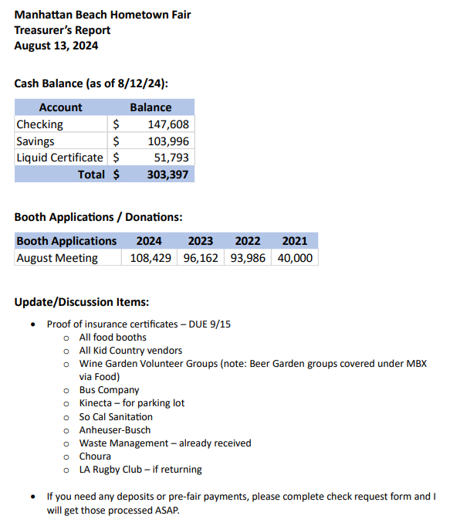

* Jeanna sent follow-up note on COI detail. **Ping Jeanna with any Qs. Due 9/15.**

7:30  Committee progress: Parade, Storage – (Ryan, Kim) +++

<https://docs.google.com/spreadsheets/d/1_epJDiSljVx1slpaUlM4MPWo4heLXSYvEiYO2dYusWo/edit#gid=0>

* Storage: Goal to have shelves installed by end of August
* Parade: Dana to talk w Rusher: No woodies this year, but will offer parking of the cars on 15th. Dana sent note on 8/16. Ryan et al to keep making updates and share at next meeting.
* Ryan to ensure that bands know not to use Joslyn CS areas for changing. Joe T provided verbiage.

7:45 Around the room

* Dana – thank you to those that represented MBHF at Neptunian’s national night out; ~$125 in donations collected, and shared new logo
* Joe T:
  + 30 min slots allowing more acts this year;
  + Please remind Mira Costa band that Joslyn green room is not changing room
* Tamarie:
  + Over 195 vendors!
  + Please let tamarie know if you would like to discuss anything with her as MAL;
  + **REQUEST: Need volunteer for last dinner**
* Kim: Lots of activity in Civic & Community place; donated remaining sweatshirts to mission
* Dana for Nicky: Balloon guy booked, and will stay in Kid Country
  + new pony and petting zoo vendor booked
  + Looking into age limit signage this year for inflatables
* Dana for Nikol:
  + Nikol can help w your signage branding questions, as needed.
  + beach reporter ad in process soon - she will circulate for input
  + Please send her updates for her back-to-school newsletter
* Wayne: Will be sending draft BBQ attendee list for your review
* Erin: All good ; scheduling info session for wine volunteers
* Bruce: pre meeting w police scheduled;
  + parking passes finalized; Bruce to PDF and send to each member
  + **All – ping him/Dana with any Qs pertinent to your venue**
* Mark: all booked except 1 slot; battle of the bands in works, update next meeting
* Robin: John Dietz not available this year; Hyperion Outfall Serenaders retired; working Taylor Nation possibility (but probably not, given tight turnaround from LAX).
* Kari: Planning short sleeve, long sleeve, mug, hat, hoodie
  + Stay tuned for board member order discount
  + All - Let Kari know if need any blue fair official shirts
* Val: Still working on game signups – school starting next week so expecting more; have some cool prizes;
  + Dana confirmed yesterday that Golf is in this year
* Ryan: Corporate donors in progress; working w Simms for year-end dinner; raffle includes Ebikes. La Kings, photo pkg and potential Terranea stay
  + Ryan/Joe M to work on asst chair for Ryan
  + Keep Ryan posted if you have any ideas
* Alex/Kimi
  + Health dept appears smoother this year; need volunteers to man bathrooms while health dept touring.
  + **Ice – do you want to pay someone to handle it?**
    - **Request from Dana– include parks and rec to any communication w health dept**
  + No news on fish tacos; ice guy booked; Sr Citizen donuts will operate as food vendor, but waiving MBHF fee
* Robert: Brought radios to share. Will have enough of both kinds for everyone, as well as extras
* **OPEN ITEM –Van size and use**. Kim suggested renting a larger van. Dana to lead
* Joe M: Let him know of any volunteer requests; Kari noted that she needs volunteers who can handle money in merch. Joe Franklin volunteered to be a floater after 10K.
* Karen:
  + City letter updates complete; meeting w/ City on Aug 20th
  + Please make sure your mobile number is up to date for our emergency cards - will be provided at safety meeting.

8:30 – 8:35 pm Final notes and off to optional Happy hour

* Next meeting August 27th

*Robert. made a motion to adjourn at 8:38 pm. Kim seconded. All in favor. Meeting adjourned.*

Minutes Approved by:

___________________________ ______________________

Dana Old, President Karen Tokashiki, Secretary