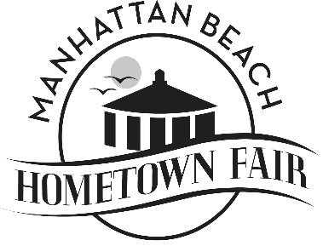 | Executive Board Meeting Minutes  Date: 9/17/24  Time: 6:00 pm Meeting  Location: Nick’s

In Attendance:
Wayne Bush | Y
Tamarie Cuneo | Y
Jeanna Harkenrider | Y
Dana Old | Y
Karen Tokashiki | Y

Discussion
- Personal check-in - around the room
- Update on Tent permit
- Staying close together as a team during fair weekend
- 9/24/24 Meeting prep
- Year end dinner
- BBQ
- Mike Johnson passing and plans to honor
- Next eboard meeting October 15th

