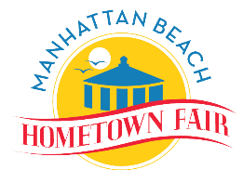

**2024 “Quarterly” Executive Board Meeting Schedule**

**Optional - Consider same days and prior to Board meeting**

*(Subject to change) 10/24 DRAFT*

|  |  |  |  |
| --- | --- | --- | --- |
| **Date** | **Time** | **Location** | **Topics** |
| **Thursday, December 20, 2023** | 6pm | Joeys | Kickoff planning |
| **Thursday Feb 1** | 6:00-7:30pm | Rockefeller’s | Objectives for year – Continue topics in Google doc |
| **March 26** | 5:00pm (Prior to social) | Hennessey’s | April 9th meeting  Retreat  New member meeting |
| **Thursday April 25 ~~18~~** | 6:00-7:00pm  7:00-9:30pm | TBD | **Meet the new board members.**  Initiatives & Retreat Prep |
| **Thursday June 18** | 6:00-7:30 | ZOOM | TBD |
| **~~Thursday~~**  **~~July 18~~** | ~~6:00-7:30pm~~ | ~~ZOOM~~ | **~~Prep for City Council meeting~~** |
| **Thursday**  **September 19th** | 6:00-7:30pm | TBD | Final Executive Meeting Prior to Fair |
| **Thursday October 13th** | 6:00-7:30pm | ZOOM | Election planning and Final 2024 Executive board meeting |