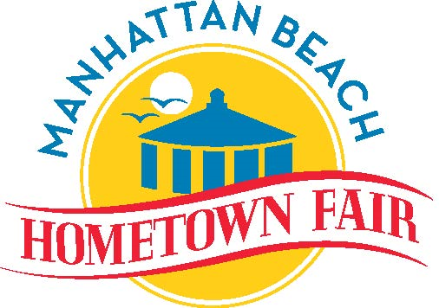

**2024 ELECTRICITY REQUIREMENTS (DRAFT R1a) – September 2024**

**Make sure walkway covers are placed over the power cords at all entrances/exists and walkways.**

**MAIN STAGE – Mark F.**

50-amp twistlock (standard).

220v (made up of 2 legs of 110v each).

From sound man: “I use the plug that is used by the Portastage. In other words, the 50-amp twist-lock on the cable that opens the roof on the trailer goes into my distro after the roof is up. If the electricians want to do something different, we could have them give me four separate 20amp circuits behind the stage and I can make it work.”

**DIETZ STAGE – Robin**

2 independent 20 amp circuits located behind stage.

**IN FRONT of Joslyn:**

One (1) 110V 20-amp power connection for PA System that will be used during parade) **– Ryan,** as well as cash machine at merchandise booth **- Kari**

**FOOD –Alex/Kimi**

All of the 3-station hot/cold sinks on the maps provided require 110-volt 20-amp power. **Map to be provided with electricity requirements.**

**BEER GARDEN/MONEY TENT – Wayne.**

Two 110V 20-amp power for counting machine and calculator.

One 110V 30-amp power for Seltzer camper.

Two 110V 20-amp power plug for ATM machines (included in ATM count below)

**INFORMATION BOOTHS - Kim**

One 110V 20-amp power plug needed in each of 2 booths for the speaker/microphones. One booth is on Dorsey and other is on Live Oak field.

**WINE GARDEN – Erin**

One 110V 20-amp power plug for musicians  
One 110V 20 amp (standard 3-prong) power plug for Bud trailer generator (Dedicated)

**ICE Truck south of Wine Garden – Erin/Alex/Kimi**

One 20 amp (standard 3-prong) 110-115 volt power

**KID COUNTRY - Nicky**

* 80 amps total Power for 3 inflatable games on the west side of Veterans Parkway between 17th and 18th streets – 20 amps each for 4 blowers.  
  Note: 1 inflatable requires (2) 20 amp plugs from the same outlet = 40 amp, other two are singular 20 amp plugs.
* 110V 20-amp power for Amplifiers, speakers, and equipment for the Wildlife/Magician Show located at Valley on the southwest side of the walk.
* 110V 20-amp power for Kid Country Information Booth microphone and amplifier – northwest entrance corner of Veterans Parkway and 17th.

**FRIDAY NIGHT BBQ – Wayne**

* Power for the musicians
  + 360 watts for the PA
  + 100 watts for the bass amp
  + 30 watts for the guitar amp

**ATM Machines – Kim/Karen**

110V 20-amp power plug for each of 7 ATM machines:

* 2 next to Joslyn parking lot, east of MB Chamber building
* 2 on Live Oak Field (1 at each entrance)
* 1 on Dorsey Field (at the entrance)
* 2 inside the beer garden.
  + Details:
    - The requirements are 3 amps per ATM. Each location can have up to two machines, so 6 amps per location.
    - Power Consumption (Idle) ‡ 0.6A @ 115 VAC at 60 Hz.
    - Power Consumption (Max Load) ‡ 250 Watts @ 120VAC.
    - Current (Max) ‡ 2.2A @ 115 VrMS at 60 Hz.
    - Voltage. ‡ 90 Y 136 VrMS @ 50/60 Hz.